Version 1.0

Revision History

|  |  |  |  |
| --- | --- | --- | --- |
| **Date** | **Version** | **Description** | **Author** |
| 22/12/2019 | 1.0 | details | Tran Van Dat |
|  |  |  |  |
|  |  |  |  |
|  |  |  |  |

Table of Contents

1. Introduction 4

1.1 Purpose 4

1.2 Scope 4

1.3 Definitions, Acronyms, and Abbreviations 4

1.4 References 4

1.5 Overview 4

2. Business Use-Case Name 4

2.1 Brief Description 4

3. Goals 4

4. Performance Goals 4

5. Workflow 5

5.1 Basic Workflow 5

6. Risk 5

7. Possibilities 5

8. Process Owner 5

9. Special Requirements 5

10. Extension Points 6

Business Use-Case Specification: Feedback

# Introduction

## Purpose

The purposes of this business use-case is to show how the computer shop deals with the situation when customer gives feedback.

## Scope

The scope of this business use-case is associated with the computer shop to be deployed

## Definitions, Acronyms, and Abbreviations

User – a person who use the system, can be customer or admin.

Admin – a person who work for the computer shop.

Customer – a user who is not logged in the system.

## References

## Overview

The rest of the Business Use-case Specification contains goal, risk, process owner and special requirement.

# Business Use-Case Name

## Brief Description

The use-case here is that “Feedback”, which means in a specific situation, the buyer add feedback after using products.

# Goals

The goal of the business use-case is to help the client have an overview of feedback.

# Performance Goals

This perfomance goal is about the final state of the use case when customer do a feedback.

# Workflow

# The buyer clicks the feedback button. Then he clicks add feedback, enter the information and submit.

## Basic Workflow

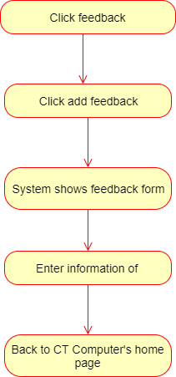

# Risk

No special.

# Possibilities

No special.

# Process Owner

No special.

# Special Requirements

No special.

# Extension Points

# No special